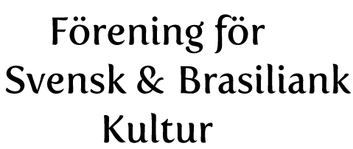
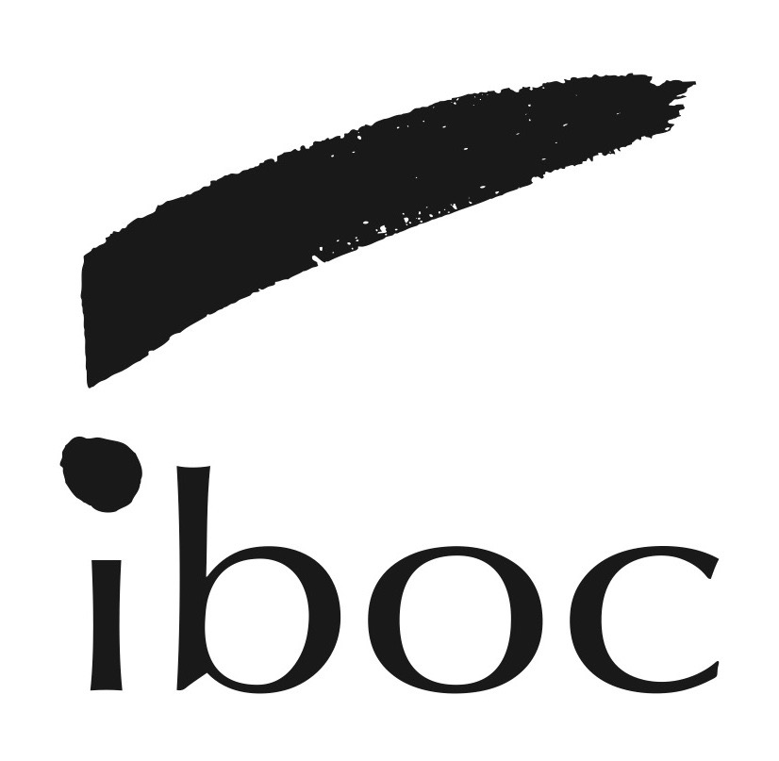
International Brazilian Opera - Application Form
THE SEVENTH SEAL
FIRST AND LAST NAMES:
VOICE FACH:
ROLES INTERESTED IN: PRINCIPAL __ CHORUS__ Would you be interested in singing in the chorus if you are not chosen for a principal role? Yes__No__ As an understudy? Yes__ No__
PREFERRED AUDITION DATE/AVAILABILITY (you may check more than one day):
March 19th___, March 20th___, March 21st____.
ARE YOU BASED IN STOCKHOLM? Yes___ If No, Where? _______________

EMAIL ADDRESS:__________________________________
CELL PHONE: _____________________________________

AUDITION REPERTOIRE:
PIECE OF STANDARD REPERTOIRE:
ARIA ______________________________
OPERA_____________________________
COMPOSER_________________________

HAVE YOU SUNG IN SWEDISH or KNOW SWEDISH DICTION?
Yes__Elaborate, please: ______________________No__
AVAILABILITY: This production is the preliminary stage for a multinational production. Singers will be considered for touring. What is your availability between May and November 2018? ____

