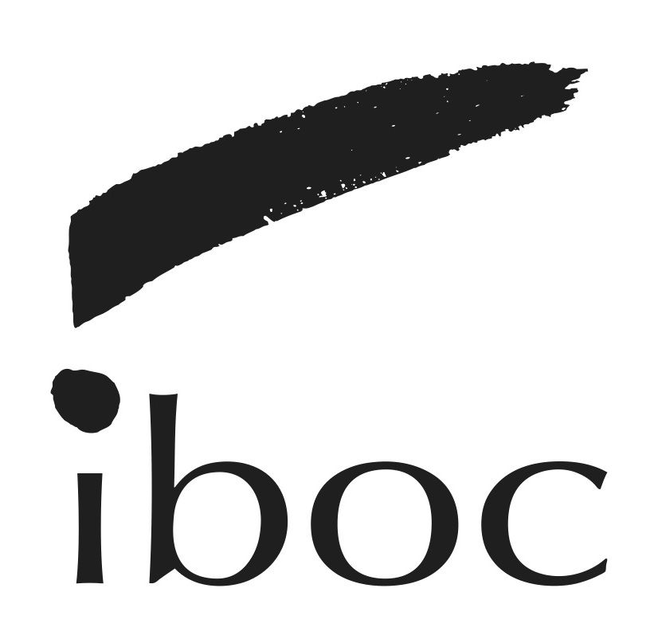
International Brazilian Opera Company
Application Form

FIRST AND LAST NAMES:
EMAIL ADDRESS:
CELL PHONE:

MUSICAL AND ARTISTIC EXPERIENCE:

INTERESTS:

WHICH PROGRAMS WOULD YOU BE INTERSTED IN ATTENDING?

OTHER ARTISTIC EXPERIENCE:

OTHER BUSINESS ANGD TECH SKILLS:
Areas, such as technology, production, promotion, accounting, business relations, fund raise, grant writing, creative writing, producing visual content, theater and dance?
Please tell us about it:

FOR SINGERS - VOICE FACH:
Would you be interested in singing in the chorus and chamber ensemble?

Why do you want to join IBOC?

LIVING & PRACTICAL:
Do you currently live in the New York Área, or are you able to travel to NY to attend classes and rehearsals?

If you are not in New York, do you think we can get a group in your community for IBOC to provide seminars, classes and performances?

If you are not a US citzen or permanent resident: Do you need help to obtain VISA? Would you be looking at a student VISA ora n Artist working permit such as an O1 VISA?

Are you interested in Joining our Professional Artists Agencing Program?

Link to Portfolio:

