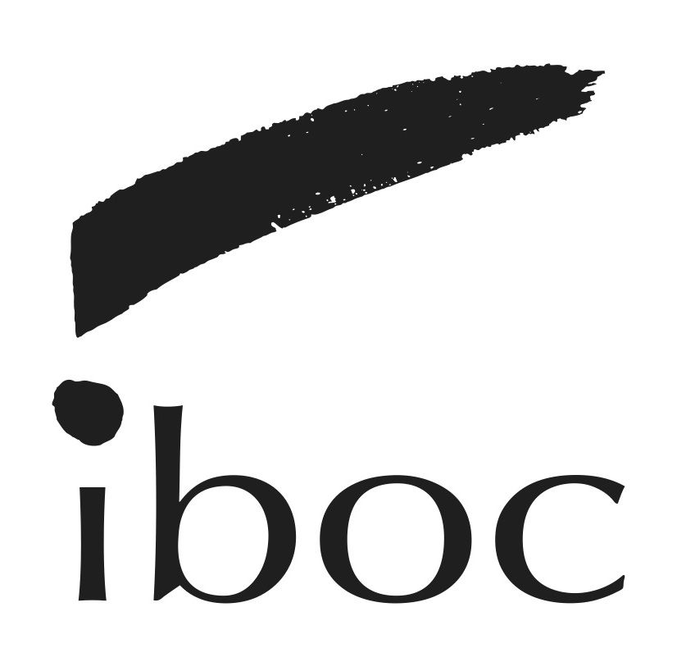
International Brazilian Opera Company
Application Form

FIRST AND LAST NAMES:
EMAIL:
CELL PHONE:
ADDRESS:

MUSICAL AND ARTISTIC EXPERIENCE:

INTERESTS:

WHICH PROGRAMS WOULD YOU BE INTERSTED IN ATTENDING?

Why do you want to join IBOC?

FOR SINGERS - VOICE FACH:
Would you be interested in singing in the chorus and chamber ensemble?

FOR INSTRUMENTALISTS – INSTRUMENT:
Would you be interested in joining one of IBOC’s performing Units? Which one(s)?

OTHER ARTISTIC EXPERIENCE:
Areas such as: theater, dance, scenography, film-making, projection/visual art, or others?

OTHER BUSINESS, PRODUCTION AND TECH SKILLS:
Areas such as: production, promotion, accounting, business relations, non-profit administration, fund raise, grant writing, creative writing, performance technology, producing visual content, or others?

Please tell us about you other areas of experience:

LIVING & PRACTICAL:
Do you currently live in the New York Área, or are you able to travel to NY to attend classes and rehearsals?

If you are not in New York, do you think we can get a group in your community for IBOC to provide seminars, classes and performances?

If you are not a US citzen or permanent resident: Do you need help to obtain VISA? Would you be looking at a student VISA ora n Artist working permit such as an O1 VISA?

Are you interested in Joining our Professional Artists Agencing Program?

Any other information about you anbd your career goals that you would like to tell us about:

Link to Portfolio:

